1. Organisation Overview:
- Name: MajorCarX
- MajorCarX is a South African automotive content business that creates engaging digital content for car enthusiasts. The business focuses on showcasing performance vehicles, car reviews, automotive events, and other car-related content across its social media platforms.
- MajorCarX aims to create high-quality automotive content that informs and entertains car enthusiasts. The business focuses on building a strong and engaged online community.
- Car show and events.
2. Website Goals and Objectives:
- The website's primary goal is to attract new visitors, showcase automotive content, and help followers learn more about MajorCarX and its services.
- The website's success will be measured by tracking website visits, social media engagement, and contact enquiries.
3. Current Website Analysis (if applicable):
- The organization has no website yet.

- To address the identified weaknesses, MajorCarX should implement an interactive, image-backed vehicle catalogue, create dedicated local search landing pages for key Gauteng areas, and deploy a multi-step enquiry form to capture precise customer and vehicle requirements.
4. Proposed Website Features and Functionality:
  - The website must combine a stunning visual portfolio of past events with an interactive booking and rental tool to convert visitors into clients seamlessly. 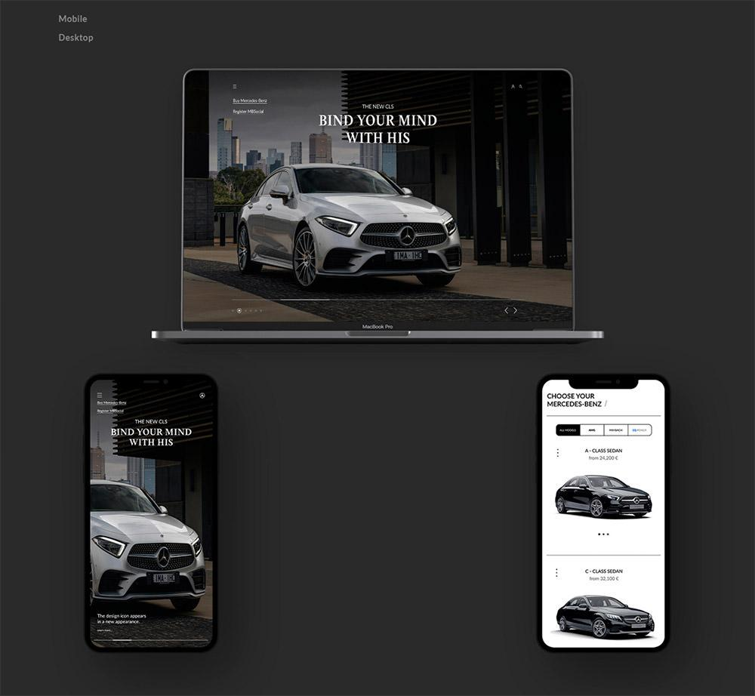
5. Design and User Experience:
  - Colour Scheme: The website uses a mix of black and clean white, with touches of warm gold to feel fancy and professional. The black and white make everything look neat and easy to read, while the gold pops out on buttons to show you exactly where to click.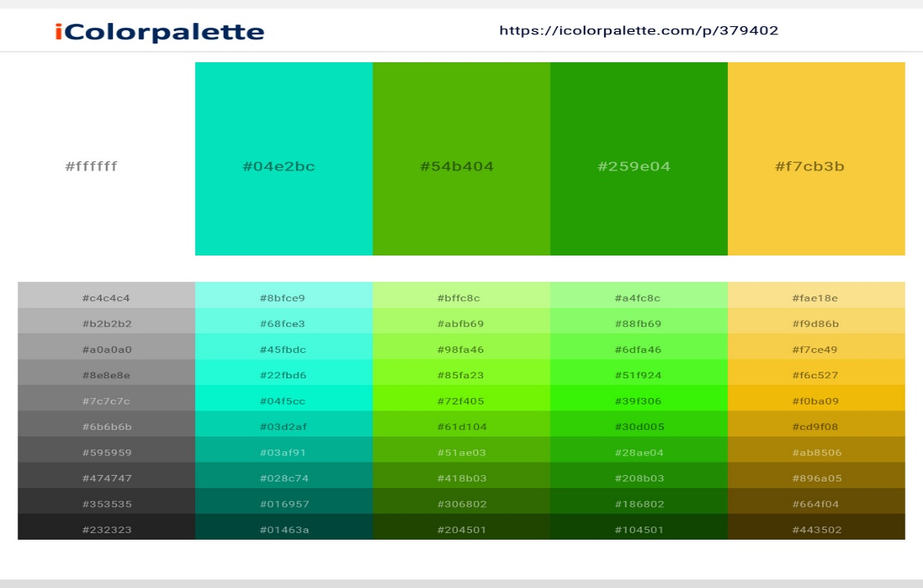
  - Typography: We use a stylish, elegant font for big titles to show off the creative side of the business.
  - Layout and Design: The look is very clean and uncluttered, with lots of breathing room and big, beautiful photos of past events.
  - User experience considerations: The site is easy to navigate, loads fast, and automatically fits perfectly on mobile screens so visitors can browse photos and book events without any frustration.
- These low-fidelity wireframes map out the desktop and mobile structures for the MajorCarX website, positioning key services and quote forms where visitors can easily find them.
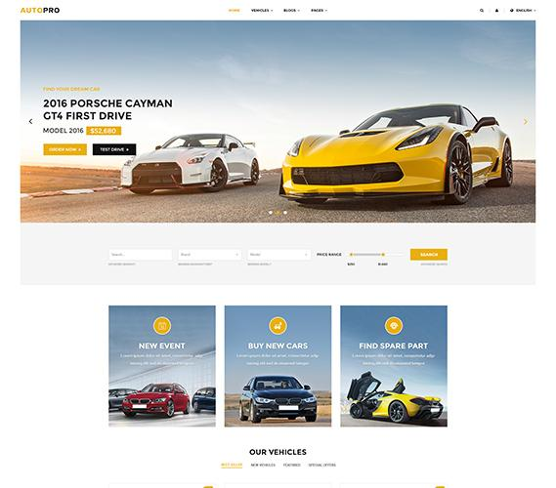
6. Technical Requirements:
- To launch the site, you need a local .co.za domain and web hosting, which can be easily built using standard HTML, CSS, and JavaScript or a simple WordPress setup.
7. Timeline and Milestones:
  - Milestone 1 (Planning): From August 11 to August 21, map out the sitemap, design layouts, and gather event photos.
Milestone 2 (Development): From August 24 to September 11, set up the web hosting, code the pages, and build the rental catalogue.
Milestone 3 (Testing & Launch): From September 14 to September 23, test all booking forms for errors and launch the final site before the spring holiday.
8. Budget:
  - The estimated website development cost for MajorCarX is between R6 000 and R16 000, depending on the website features and level of customisation required.
  - Web hosting is estimated at approximately R100 per month, while a .co.za domain is expected to cost approximately R100 to R200 per year.
  - Ongoing website maintenance is estimated at approximately R1 000 to R5 000 per month, depending on the amount of content updates, technical support, and website management required.

9. References:
- The project proposal references include relevant South African automotive websites alongside local web design hosting, and UX standards to ensure realistic pricing and development guidelines.

